# Instruction Memory

Each instruction has its own address, marked by the 32-bit vector of the program counter. When a given instruction is needed, the Instruction Memory delivers a 32-bit wide instruction. The following considerations have to be taken into account for the Instruction Memory:

• Each instruction is one word long (32 bits).

• Each instruction is addressed by a multiple of 4 bytes (1 word).

• Each instruction lies at a multiple of 4 bytes. By contrast, the program counter counts in terms of bytes. To avoid systematic “jumps” by four instructions when the new program counter is proposed, the program counter is divided by 4.

• At the rising edge of w_clk, we write the value of the wd into instruction memory. In this way, it can support changing the program while our processor is running on the FPGA.

Test:

Random generate 1000 test cases.

1. Generate random variable to change addr(9 downto 2) and random variable to change instruction
2. When stage equals to finished, all the test case passed.

Function Simulation:

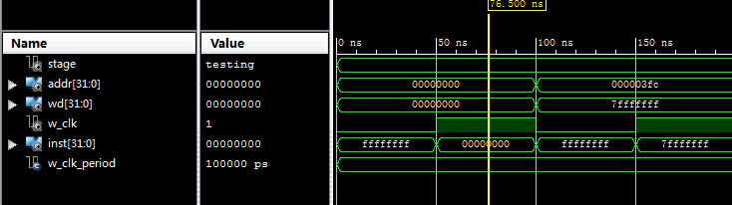

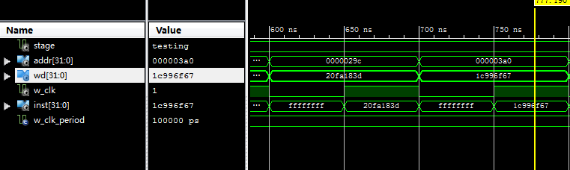

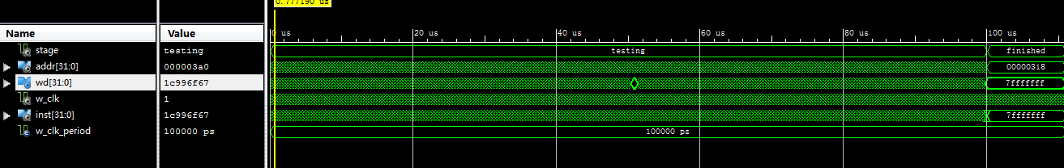

Timing Simulation:

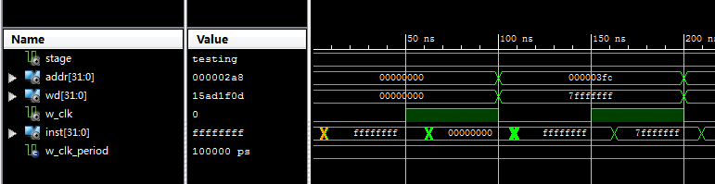

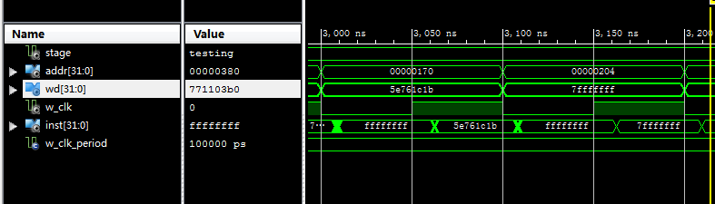

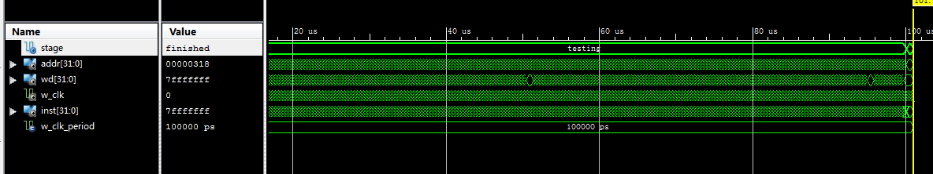

Latency:

It takes 100000ns to get the result of 1000 test case. Clock period=100ns, so it’s 1000 clock cycles.

RC5 part:

(1)

ukey = 0x91cea91001a5556351b241be19465f91

A_in = 0xeedba521

B_in = 0x6d8f4b15

Functional simulation:

A_enc = AC13C0F7

B_ enc = 52892B5B

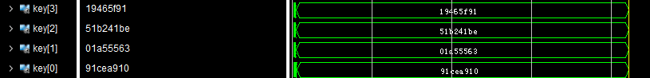

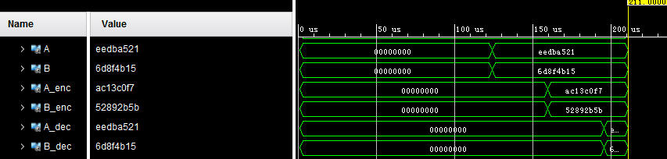

period: 10ns

It takes 160000ns to encode, about 16000 cycles.

It takes 196825ns to decode, about 19682 cycles.

(2)

ukey = 0x00000000000000000000000000000000

A_in = 0x00000000

B_in = 0x00000000

A_enc = eedba521

B_enc = 6d8f4b15

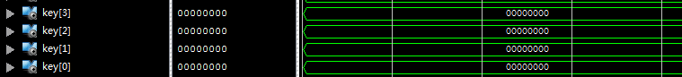

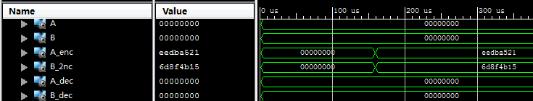

(3)

ukey = 8767C18DBB69B1D72F0FEB5AE7483378

A_in = AC13C0F7

B_in = 52892B5B

A_enc = B7B3422F

B_enc = 92FC6903

